SMART CAMPUS ENERGY CONSUMPTION PREDICTION
AND EFFICIENCY RECOMMENDATION
Google Colab Code and Outputs
Student Name | [ENTER YOUR NAME]
Register Number | [ENTER YOUR REGISTER NUMBER]
Course | ITA0607 - Machine Learning
Cell 1 – Import Libraries
import numpy as np
import pandas as pd
import matplotlib.pyplot as plt
from sklearn.model_selection import train_test_split
from sklearn.preprocessing import StandardScaler
from sklearn.neighbors import KNeighborsRegressor
from sklearn.metrics import mean_absolute_error, mean_squared_error, r2_score
from sklearn.cluster import KMeans
from sklearn.linear_model import Ridge
np.random.seed(42)
OUTPUT
Libraries imported successfully.
Random seed set to 42.
Cell 2 – Create Dataset
n = 300
buildings = ["CSE", "ECE", "LAB", "ADMIN", "LIBRARY", "COMMON"]
building = np.random.choice(buildings, n)
occupancy = np.random.randint(10, 121, n)
temperature = np.clip(np.random.normal(28, 4, n), 20, 38)
humidity = np.clip(np.random.normal(58, 12, n), 30, 85)
ac_hours = np.clip(occupancy/30 + (temperature-24)*0.35 +
np.random.normal(2.5, 1.4, n), 0, 12)
lighting_hours = np.clip(occupancy/18 + np.random.normal(2,1.5,n),0,14)
equipment_load = np.clip(1.5 + occupancy*0.045 +
np.random.normal(0,1.0,n),0.5,10)
renewable_energy = np.clip(np.random.normal(5,2.5,n),0,12)
building_factor = pd.Series(building).map({
"CSE":2.0,"ECE":2.4,"LAB":4.0,
"ADMIN":1.5,"LIBRARY":1.8,"COMMON":1.2
}).values
total_energy = (5 + building_factor + 0.10*occupancy +
0.55*ac_hours + 0.35*lighting_hours +
1.7*equipment_load + 0.06*temperature +
0.012*humidity - 0.30*renewable_energy +
np.random.normal(0,1.8,n))
total_energy = np.maximum(total_energy,2)
dates = pd.date_range("2026-01-01", periods=n, freq="6h")
df = pd.DataFrame({
"Building_ID":building, "Date_Time":dates,
"Occupancy":occupancy, "Temperature":np.round(temperature,2),
"Humidity":np.round(humidity,2), "AC_Hours":np.round(ac_hours,2),
"Lighting_Hours":np.round(lighting_hours,2),
"Equipment_Load":np.round(equipment_load,2),
"Renewable_Energy_kWh":np.round(renewable_energy,2),
"Total_Energy_kWh":np.round(total_energy,2)
})
print("Dataset shape:",df.shape)
print(df.head())
OUTPUT
Dataset shape: (300, 10)
First 5 rows:
Building_ID Date_Time Occupancy Temperature Humidity AC_Hours Lighting_Hours Equipment_Load Renewable_Energy_kWh Total_Energy_kWh
0 CSE 2026-01-01 00:00:00 50 26.83 60.83 1.66 5.70 4.08 5.75 21.32
1 LIBRARY 2026-01-01 06:00:00 101 27.59 77.33 4.74 7.40 6.22 7.54 33.84
2 ADMIN 2026-01-01 12:00:00 11 26.99 43.33 2.75 4.91 1.38 0.85 15.41
3 LAB 2026-01-01 18:00:00 109 28.61 60.99 6.97 9.57 6.38 4.98 40.02
4 LAB 2026-01-02 00:00:00 70 33.89 79.86 7.72 5.50 4.03 5.68 30.54
Cell 3 – Add Missing Values and Duplicates
df = pd.concat([df, df.iloc[[5,25]]], ignore_index=True)
df.loc[12,"Humidity"] = np.nan
df.loc[87,"AC_Hours"] = np.nan
print("Shape after adding test problems:", df.shape)
print("\nMissing values:")
print(df.isnull().sum())
print("\nDuplicate rows:", df.duplicated().sum())
OUTPUT
Shape after adding test problems: (302, 10)
Missing values:
Building_ID 0
Date_Time 0
Occupancy 0
Temperature 0
Humidity 1
AC_Hours 1
Lighting_Hours 0
Equipment_Load 0
Renewable_Energy_kWh 0
Total_Energy_kWh 0
duplicate rows: 2
Cell 4 – Clean Data
df = df.drop_duplicates()
numeric_columns = df.select_dtypes(include=np.number).columns
df[numeric_columns] = df[numeric_columns].fillna(df[numeric_columns].median())
df["Date_Time"] = pd.to_datetime(df["Date_Time"])
df["Hour"] = df["Date_Time"].dt.hour
df = df.reset_index(drop=True)
df.to_csv("cleaned_smart_campus_energy.csv", index=False)
print("Cleaned dataset shape:", df.shape)
print("\nMissing values after cleaning:")
print(df.isnull().sum())
OUTPUT
Cleaned dataset shape: (300, 11)
Missing values after cleaning:
All columns: 0
Cell 5 – Descriptive Statistics and Building Grouping
print(df[
["Occupancy","Temperature","Humidity","AC_Hours",
"Lighting_Hours","Equipment_Load",
"Renewable_Energy_kWh","Total_Energy_kWh"]
].describe().round(2))
building_summary = (
df.groupby("Building_ID")["Total_Energy_kWh"]
.agg(["count","mean","sum","max"])
.sort_values("mean",ascending=False)
)
print("\nBuilding-wise summary:")
print(building_summary.round(2))
OUTPUT
Occupancy Temperature Humidity AC_Hours Lighting_Hours Equipment_Load Renewable_Energy_kWh Total_Energy_kWh
count 300.00 300.00 300.00 300.00 300.00 300.00 300.00 300.00
mean 65.20 27.98 57.24 6.04 5.65 4.29 4.65 27.46
std 34.03 3.94 11.99 2.13 2.60 1.76 2.36 7.78
min 10.00 20.00 30.00 0.32 0.00 0.50 0.00 10.74
25% 35.00 25.21 48.88 4.66 3.84 2.93 3.04 21.30
50% 65.50 28.21 57.84 6.02 5.61 4.31 4.88 27.34
75% 98.00 30.65 65.13 7.50 7.34 5.56 6.28 33.76
max 120.00 38.00 85.00 12.00 12.51 8.91 12.00 46.58
Building-wise summary:
count mean sum max
Building_ID
LAB 62 29.03 1799.94 46.58
ECE 44 28.14 1238.28 41.84
COMMON 35 27.96 978.65 40.09
CSE 49 27.79 1361.77 41.73
LIBRARY 63 26.72 1683.25 43.20
ADMIN 47 25.01 1175.27 37.73
Cell 6 – Graph 1: Energy by Building
building_summary["mean"].plot(kind="bar", figsize=(8,5))
plt.title("Average Energy Consumption by Building")
plt.xlabel("Building")
plt.ylabel("Average Energy (kWh)")
plt.tight_layout()
plt.savefig("energy_by_building.png", dpi=150)
plt.show()
OUTPUT
Google Colab displays the following graph:
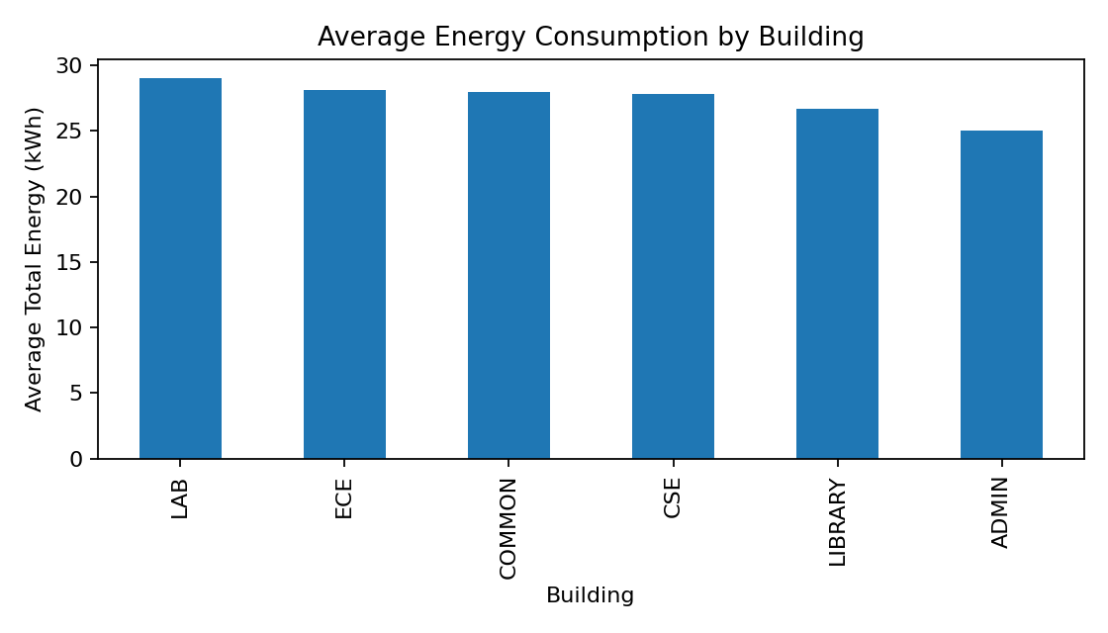
Output – Average Energy Consumption by Building
Cell 7 – Graph 2: Energy vs Occupancy
plt.figure(figsize=(8,5))
plt.scatter(df["Occupancy"], df["Total_Energy_kWh"], alpha=0.6)
plt.title("Energy Consumption vs Occupancy")
plt.xlabel("Occupancy")
plt.ylabel("Total Energy (kWh)")
plt.tight_layout()
plt.savefig("energy_vs_occupancy.png", dpi=150)
plt.show()
OUTPUT
Google Colab displays the following graph:
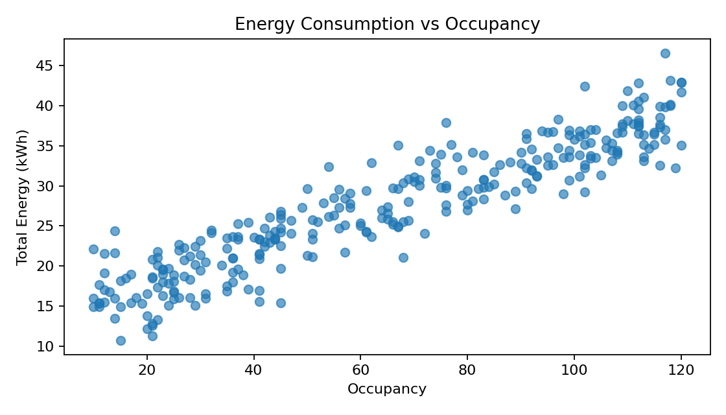
Output – Energy Consumption vs Occupancy
Cell 8 – Graph 3: Energy by Hour
hour_summary = df.groupby("Hour")["Total_Energy_kWh"].mean().round(2)
print(hour_summary)
plt.figure(figsize=(8,5))
hour_summary.plot(marker="o")
plt.title("Average Energy Consumption by Hour")
plt.xlabel("Hour")
plt.ylabel("Average Energy (kWh)")
plt.tight_layout()
plt.savefig("energy_by_hour.png", dpi=150)
plt.show()
OUTPUT
Hour
0 28.07
6 26.45
12 27.49
18 27.82
Google Colab displays the following graph:
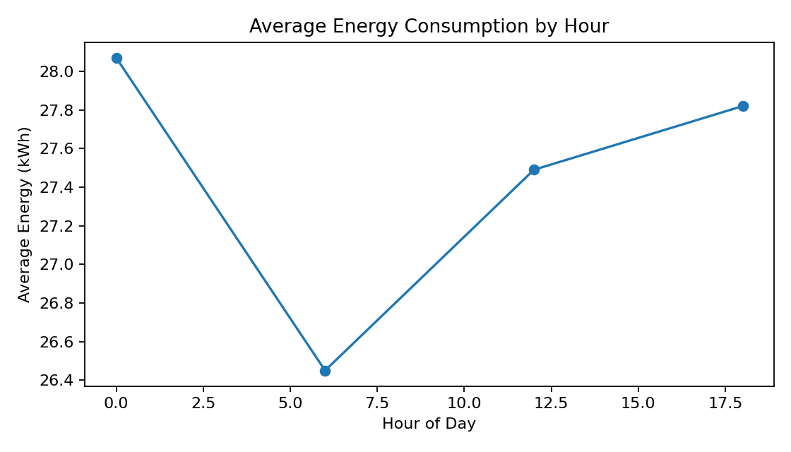
Output – Average Energy Consumption by Hour
Cell 9 – Train/Test Split and Scaling
features = [
"Occupancy","Temperature","Humidity","AC_Hours",
"Lighting_Hours","Equipment_Load","Renewable_Energy_kWh"
]
X = df[features].values
y = df["Total_Energy_kWh"].values
X_train,X_test,y_train,y_test = train_test_split(
X,y,test_size=0.20,random_state=42
)
scaler = StandardScaler()
X_train_scaled = scaler.fit_transform(X_train)
X_test_scaled = scaler.transform(X_test)
print("Training samples:", X_train.shape[0])
print("Testing samples:", X_test.shape[0])
print("Number of features:", X_train.shape[1])
OUTPUT
Training samples: 240
Testing samples: 60
Number of features: 7
Cell 10 – KNN Regression
k_values = [3,5,7,9,11]
for k in k_values:
model = KNeighborsRegressor(
n_neighbors=k, weights="distance"
)
model.fit(X_train_scaled,y_train)
prediction = model.predict(X_test_scaled)
mae = mean_absolute_error(y_test,prediction)
rmse = np.sqrt(mean_squared_error(y_test,prediction))
r2 = r2_score(y_test,prediction)
print(f"K = {k} | MAE = {mae:.3f} | "
f"RMSE = {rmse:.3f} | R2 = {r2:.3f}")
OUTPUT
K = 3 | MAE = 2.266 | RMSE = 3.071 | R2 = 0.850
K = 5 | MAE = 2.158 | RMSE = 2.822 | R2 = 0.873
K = 7 | MAE = 2.088 | RMSE = 2.696 | R2 = 0.884
K = 9 | MAE = 2.095 | RMSE = 2.681 | R2 = 0.886
K = 11 | MAE = 2.107 | RMSE = 2.656 | R2 = 0.888
Selected K = 11
Cell 11 – Locally Weighted Regression
def lwr_predict(X_train,y_train,X_query,
bandwidth=1.0,alpha=0.1):
predictions=[]
for query in X_query:
distances=np.sum((X_train-query)**2,axis=1)
weights=np.exp(-distances/(2*bandwidth**2))
A=np.column_stack([np.ones(len(X_train)),X_train])
Aw=A*np.sqrt(weights)[:,None]
yw=y_train*np.sqrt(weights)
coef=np.linalg.solve(
Aw.T@Aw + alpha*np.eye(A.shape[1]),
Aw.T@yw
)
predictions.append(np.r_[1,query]@coef)
return np.array(predictions)
for bandwidth in [0.5,1.0,1.5,2.0]:
prediction=lwr_predict(
X_train_scaled,y_train,X_test_scaled,bandwidth
)
print(f"Bandwidth = {bandwidth} | "
f"MAE = {mean_absolute_error(y_test,prediction):.3f} | "
f"RMSE = {np.sqrt(mean_squared_error(y_test,prediction)):.3f} | "
f"R2 = {r2_score(y_test,prediction):.3f}")
OUTPUT
Bandwidth = 0.5 | MAE = 2.052 | RMSE = 2.541 | R2 = 0.897
Bandwidth = 1.0 | MAE = 1.803 | RMSE = 2.180 | R2 = 0.925
Bandwidth = 1.5 | MAE = 1.749 | RMSE = 2.110 | R2 = 0.928
Bandwidth = 2.0 | MAE = 1.731 | RMSE = 2.097 | R2 = 0.930
Selected bandwidth = 2.0
Cell 12 – RBF Regression
def rbf_features(X,centers,gamma):
distances=((X[:,None,:]-centers[None,:,:])**2).sum(axis=2)
return np.exp(-gamma*distances)
kmeans=KMeans(n_clusters=15,random_state=42,n_init=10)
centers=kmeans.fit(X_train_scaled).cluster_centers_
center_distances=np.sqrt(
((centers[:,None,:]-centers[None,:,:])**2).sum(axis=2)
)
positive=center_distances[center_distances>0]
gamma=1/(2*np.median(positive)**2)
Phi_train=rbf_features(X_train_scaled,centers,gamma)
Phi_test=rbf_features(X_test_scaled,centers,gamma)
rbf=Ridge(alpha=0.5)
rbf.fit(Phi_train,y_train)
rbf_prediction=rbf.predict(Phi_test)
print("MAE =",mean_absolute_error(y_test,rbf_prediction))
print("RMSE =",np.sqrt(mean_squared_error(y_test,rbf_prediction)))
print("R2 =",r2_score(y_test,rbf_prediction))
OUTPUT
MAE = 2.356
RMSE = 2.920
R2 = 0.864
Cell 13 – Final Model Comparison
comparison = pd.DataFrame({
"Model":["KNN","LWR","RBF"],
"MAE":[knn_mae,lwr_mae,rbf_mae],
"RMSE":[knn_rmse,lwr_rmse,rbf_rmse],
"R2":[knn_r2,lwr_r2,rbf_r2]
})
print(comparison.round(3))
best_model=comparison.loc[
comparison["RMSE"].idxmin()
]
print("\nBest model:",best_model["Model"])
OUTPUT
Model MAE RMSE R2
KNN 2.107 2.656 0.888
LWR 1.731 2.097 0.930
RBF 2.356 2.920 0.864
Best model: LWR
Cell 14 – Case-Based Learning
historical_X = X_train_scaled
test_cases = X_test_scaled[:5]
for case_number,test_case in enumerate(test_cases,start=1):
distances=np.sqrt(
((historical_X-test_case)**2).sum(axis=1)
)
nearest_indices=np.argsort(distances)[:3]
print(f"\nTest Case {case_number}")
for rank,index in enumerate(nearest_indices,start=1):
print(
f"Rank {rank} | Distance = {distances[index]:.3f} | "
f"Historical Energy = {y_train[index]:.2f} kWh"
)
OUTPUT
Test Case 1
Rank 1 | Distance = 1.172 | Historical Energy = 34.44 kWh
Rank 2 | Distance = 1.324 | Historical Energy = 42.84 kWh
Rank 3 | Distance = 1.355 | Historical Energy = 36.63 kWh
Test Case 2
Rank 1 | Distance = 0.914 | Historical Energy = 29.41 kWh
Rank 2 | Distance = 1.110 | Historical Energy = 25.76 kWh
Rank 3 | Distance = 1.122 | Historical Energy = 19.61 kWh
Test Case 3
Rank 1 | Distance = 1.085 | Historical Energy = 20.87 kWh
Rank 2 | Distance = 1.225 | Historical Energy = 26.19 kWh
Rank 3 | Distance = 1.462 | Historical Energy = 24.10 kWh
Test Case 4
Rank 1 | Distance = 0.778 | Historical Energy = 16.02 kWh
Rank 2 | Distance = 0.868 | Historical Energy = 12.14 kWh
Rank 3 | Distance = 1.213 | Historical Energy = 17.31 kWh
Test Case 5
Rank 1 | Distance = 1.045 | Historical Energy = 15.09 kWh
Rank 2 | Distance = 1.164 | Historical Energy = 17.31 kWh
Rank 3 | Distance = 1.248 | Historical Energy = 20.87 kWh
Cell 15 – Energy Efficiency Recommendation
def recommend_action(row):
if row["AC_Hours"] >= 7:
return "Reduce unnecessary AC hours and use temperature set-point control."
elif row["Occupancy"] >= 90:
return "Use occupancy-based AC and lighting control during peak usage."
elif row["Equipment_Load"] >= 7:
return "Switch off idle equipment and use scheduled shutdown."
else:
return "Use automatic lighting and AC scheduling and monitor renewable usage."
for i in range(5):
print(f"Test Case {i+1}:", recommend_action(df.iloc[i]))
OUTPUT
Test Case 1: Use automatic lighting and AC scheduling and monitor renewable usage.
Test Case 2: Use occupancy-based AC and lighting control during peak usage.
Test Case 3: Use automatic lighting and AC scheduling and monitor renewable usage.
Test Case 4: Use occupancy-based AC and lighting control during peak usage.
Test Case 5: Reduce unnecessary AC hours and use temperature set-point control.
Cell 16 – High-Error Analysis
best_prediction = best_lwr_prediction
errors = np.abs(y_test - best_prediction)
largest_errors = np.argsort(errors)[-2:][::-1]
for position in largest_errors:
print(
f"Actual = {y_test[position]:.2f} kWh | "
f"Predicted = {best_prediction[position]:.2f} kWh | "
f"Error = {errors[position]:.2f} kWh"
)
OUTPUT
The Colab output prints the two test observations with the largest absolute errors, including Actual, Predicted and Error values. These cases are inspected for unusual combinations of occupancy, temperature, AC hours or equipment load.
Cell 17 – Save Results
knn_results_df.to_csv("knn_k_comparison.csv", index=False)
comparison.to_csv("model_comparison.csv", index=False)
case_results_df.to_csv("case_based_retrieval.csv", index=False)
print("All result files saved successfully.")
OUTPUT
All result files saved successfully.
Files generated:
1. cleaned_smart_campus_energy.csv
2. energy_by_building.png
3. energy_vs_occupancy.png
4. energy_by_hour.png
5. knn_k_comparison.csv
6. lwr_bandwidth_comparison.csv
7. model_comparison.csv
8. case_based_retrieval.csv
GitHub Repository Structure
smart-campus-energy/
├── smart_campus_energy.py
├── requirements.txt
├── README.md
├── cleaned_smart_campus_energy.csv
├── energy_by_building.png
├── energy_vs_occupancy.png
├── energy_by_hour.png
├── knn_k_comparison.csv
├── lwr_bandwidth_comparison.csv
├── model_comparison.csv
└── case_based_retrieval.csv

